2020
James Reynolds - Your Model Train Coach
http://www.JamesModelTrains.com /

Model Train Beginners Starter Guide
Do You Consider This a Dream Layout?
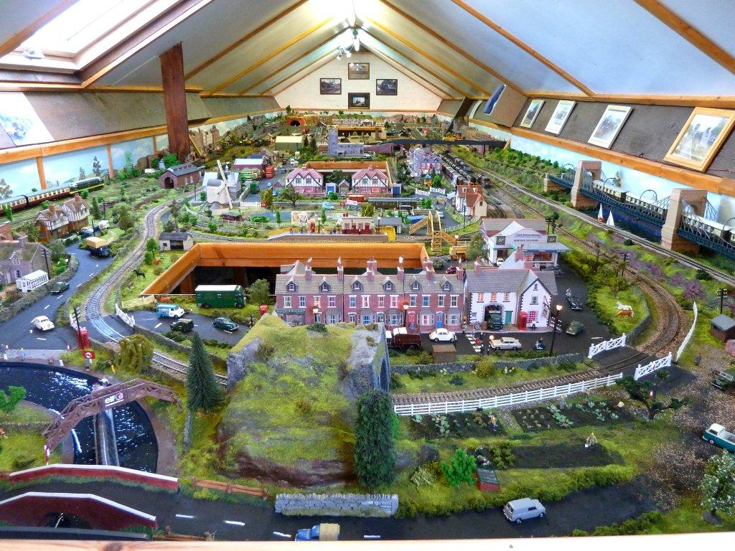
Image - Courtesy of David
"Before you can achieve an amazingly detailed layout like Dave's, every model train beginner must first learn the basics and avoid costly mistakes!"
I know you're excited about model railroading now and anxious to get started, but before you rush out and buy your first train set and begin designing your layout, there are a few things to think about...
As a model train beginner, the first two fundamental concepts you will learn today, will be the only two things you will need to know to ensure that the rest of your model train experience will go flawlessly in terms of planning. (Tips on building a model train layout will be delivered via email.)
After spending the last 25 years building model train layouts for some of the biggest model train expo’s in the United States, I still use this two step strategy while planning my model train layouts.
I am sharing this knowledge with you to make sure the “World’s Greatest Hobby” lives on for generations and you can share wonderful experiences with your friends and family building model railroads.
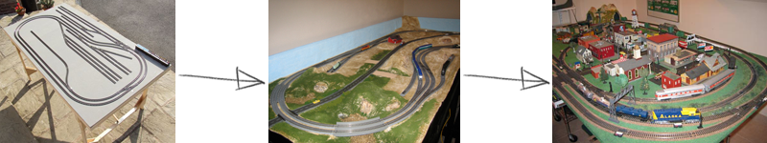
The 2 Most Important Concepts
The only two things that matter when you are preparing to start are Size or Scale and Electrical Current.
Let's dive right into size or scale:
- Size (scale): There are many model train scales but once you choose one, your entire layout revolves around that scale. Reason being, all terrain, accessories; details are scaled to a specific size, if you start mixing scales within the layout the entire realistic aspect of the layout is thrown out the window. You will end up having different size trees and tracks and one especially important error that will happen is mishaps with tracks and wiring due to the difference in scales.
- The bigger the scale the more room it acquires. Keep that in mind when choosing a scale based on the space your model train layout will have for itself. Be space conscious for indoor trains and tracks.
- Different scales are not interchangeable.

Breakdown of the two most popular scales:
- HO Scale - HO scale model trains are the most popular in the world and are responsible for a huge leap in demand due to consumer affordability dating back to around 1922. Because of its far-reaching popularity it is the most well developed scale with the largest selection of buildings, trees, tracks and everything. In this scale, 3.5 mm (0.14 in) represents 1 real foot (304.8 mm). Scale Ratio: 1/87
- Supports: DCC and DC
- HO was created after the First World War to meet the growing demand for a smaller more home friendly scale of model train. Up to this point you were stuck with O scale (very big - great for outdoors).
- O Scale - The oldest model train scale, it's been around since the 1900's. It is the biggest scale available and perhaps the best choice for that want a tough/lasting indoor set up. O scale was originally designed to be durable, affordable and capable of surviving younger hands. Because of this, most model train stuff for this scale lacks overall detail and typically is less pleasing to the eye. For less detail and more running then the O scale is good for you and also durable for younger hands.
Now let's discuss electrical current:
- DCC (digital command control): Is the best type of electrical current if you are running multiple trains at different speeds. DCC is more modern and allows for intricate layouts with numerous trains following their daily routes at varying speeds to ensure the most realistic layout possible. Just like real life, locomotives move at different speeds. Not going DCC from the start is almost futile, if you ever want to have a super realistic model train layout, you WILL have to eventually use DCC, might as well use it right off the bat.
- For modest train layouts DC (direct current) can do the trick. When you turn on the DC switch on your layout, all the trains on every different track will start moving at the same speed. Biggest real world advantage of DC is the lower cost, majority of model trains that can be purchased that run on DC are less expensive than their dynamic DCC counterparts.
Deeper Dive into Choosing the Right Scale
- Building a layout in HO scale will be almost half the size of the identical layout in O scale. Turning radius’s in HO scale will be tighter; tunnels will be smaller and, most importantly, it is easier to hide mistakes in a smaller scale.

- Larger scales need more detail and it can often be very hard to create a realistic looking layout in a large scale. HO scale has become very popular because it is a “middle-of-the-road” scale and easier to make look realistic.
- An HO scale switching layout can be created on a 4 x 1 foot table, while a continuous loop railroad will need a 3 feet 6 inch x 4 feet table. A layout space of 6 feet x 4 feet would be enough to have an interesting HO scale layout with a continuous loop.
- Still don’t have that much room available? Then consider an N scale railroad, which can be built in 30% of the area required by a similar model train layout in HO scale.
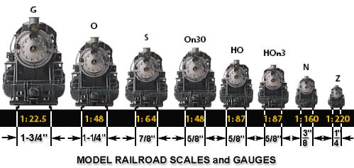
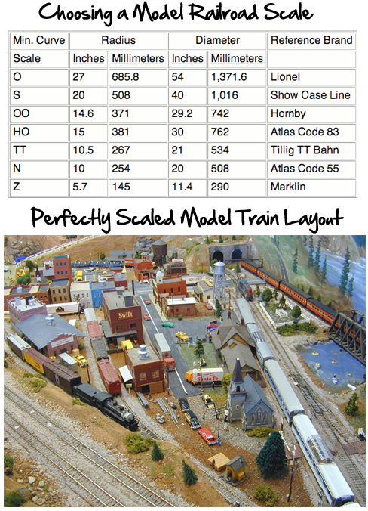
Now that you’ve got an idea of what scale to use and the type of electrical current that will drive your model railroad, the next three fundamental steps will put you on the fast track to model railroading success!
Model Railroad Theme
The first thing you should do is decide on a theme for your railroad.
- What is your railroad's purpose? Where are your trains going to and coming from and why? Are they going to carry passengers from one town to another? Will they mostly carry coal to towns or local ports, timber to lumber yards, or farm goods to markets, etc?

- What is the setting: the location and era? Where and during what time period will your trains be operating? These can be either specific or general. If you like steam trains you will want to model the era before 1955. Diesels became popular in the late 1940's and beyond. The period between 1945 and 1955, the transition era, saw both steam and diesel running the rails. The location you want to model would help you decide which particular railroads - like Union Pacific or Norfolk Southern, etc.- you want running through your layout.

- What kind of model trains or equipment do you want to run on your layout? Again the place and the time you want to model may help you decide. Or it could be the other way around. You may really want to model the Lehigh Valley Railroad because you like the colors, for example, in which case the general location and time frame would already be known.
- What type of service will your model railroad provide and to whom? What industries and/or towns will your trains be carrying goods (or people) to and from? Do you like coal-hauling, logging, farming, oil industries, passenger service?
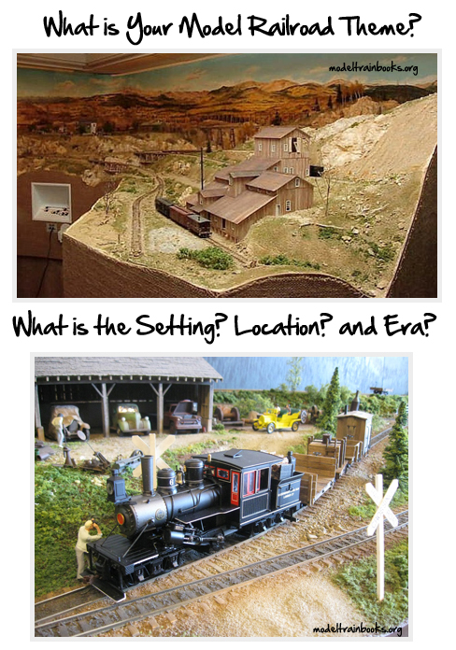Model Railroad Scale
You then need to decide on what scale to use. (Scale refers to the ratio between the measurements of a model compared to that of the prototype.) In other words what size trains do you want to run?
There are several different popular train scales available. Which one you choose depends on:
- How much space you have?
- How much money you can comfortably devote to the hobby?
- Whether you like a lot of scenery vs. more emphasis on the trains
- Do you prefer long running trains or shorter trains?
- Do you have the patience, the visual acuity, and finger dexterity to deal with very tiny engines on tiny tracks?

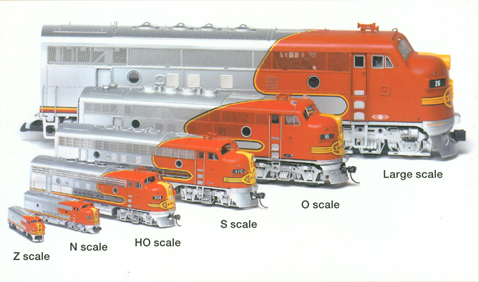
Incidentally, the words scale and gauge are often confused.

Scale refers to the ratio between the measurement of a model compared to that of the prototype.

Gauge is the term used to describe the distance between the 2 rails of track - usually 4 ft 8-1/2in ("standard gauge") in the prototype. "Narrow gauge" is a term used for rails that are closer together than standard gauge - usually around 3 to 3 1/2 ft.

Model Railroad Displays
The third thing to decide in your model railroading adventure is how you will show off and operate your trains.
- Are you building this railroad for your own enjoyment?
- Will you have friends helping you and participating in the operation of the railroad when it is completed?
- Is it mostly for your children or grandchildren to enjoy?
- Will it become part of a larger club layout?
- Do you want to build a small scene that you could sell at a craft show or on eBay?
There will most likely be some limiting factors that may enter into this decision also, such as space, time and monetary considerations.
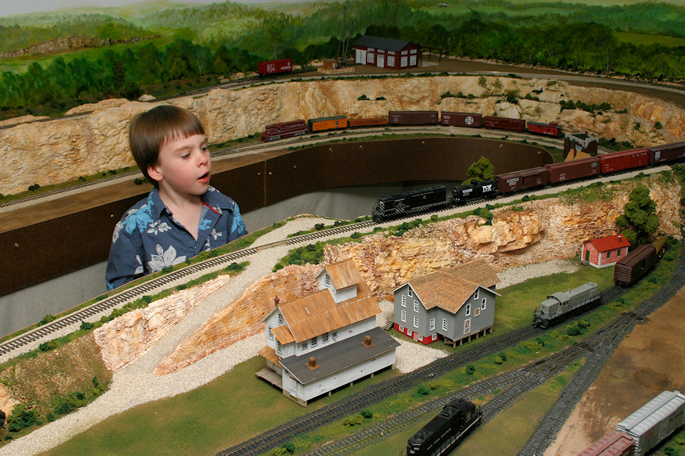

Here’s what to do next
Model trains is not necessarily an expensive habit but beginners who fall prey to the standard trial and error format of learning how to build model train layouts end up losing motivation due to the costs of making errors.
Do not go down the route of making mistakes. Instead get 24/7 access to 100's of clever model railroading ideas, and step-by-step tutorials to help you build the model train layout of your dreams…saving you time, money and frustration!
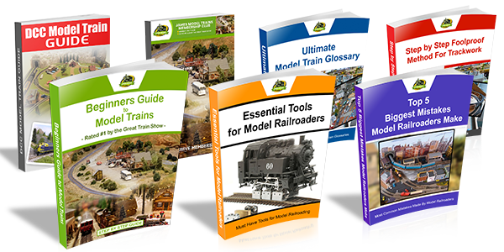
Take advantage of this limited time offer – CLICK HERE
I can honestly say that will be the most effective money spent for beginner railroaders. It may set you back a few bucks but even if the information saves you from making one big mistake, it's worth it.
The information is so valuable that it comes with a full confidence backed 60 Day Money Back Guarantee.
This guarantee allows you to get a complete refund while gaining access to 100's of tutorials, advice and secret tips!
By registering for this free report, you've also gained access to the special discount and bonus gift offer for FREE! This includes 6 bonus e-Books totaling $150 of free bonus gifts if you act TODAY.
Bonus offers include:
- Top 5 Biggest Mistakes Model Railroaders Make
- Essential Tools for Model Railroaders
- Step by Step Foolproof Method for Trackwork
- DCC Model Train Guide
- Model Railroading Glossary and Resources
- Model Train Track and Layout Plans for Beginners

Conclusion
You can see there are many things to consider when deciding what kind of railroad, you want and how you want to show it or operate it. However, don't get so hung up on the decision-making process that it prevents you from moving forward.
Okay, now that you have considered the location, the era, the scale and what type of display you want to model, you're ready for the next step.
We'll discuss the next two model train building phases in the next couple of emails, so keep a look out for those valuable emails filled with gems of railroading tips, tricks and advice.
But...
All else set aside, there's one vital step that nobody ever tells model train beginners that you MUST complete to ensure you maintain your interest and ACTUALLY complete your model railroad.
This is the secret that will put you ahead of any other model train beginner and novice builder. It's the one thing that will save you the heartache of making costly mistakes.
It will stop you some ruining your model railroad or needing to salvage your layout, if you've already made this mistake.
The secret will be revealed in the upcoming email series.
In the meantime, be sure to check out the treasure trove of valuable model train resources and gain instant access to insider information including tips, tricks and clever… with all the help you need at your fingertips!

Here's How to Get Started Quickly and Easily with Your Dream Model Railroad

